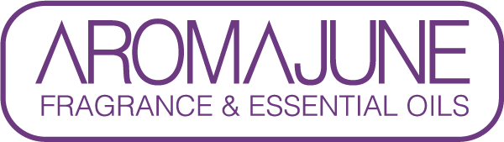

DATE : {{DATE}}
TO : {{CUSTOMER}}
SUBJCET : NITRO MUSKS CERTIFICATE
PRODUCT NAME : {{PRODUCT}}

We hereby confirm that the above-mentioned product does not contain any nitro musk substances:

- MUSK AMBRETTE (CAS 83-66-9)
- MUSK TIBETENE (CAS 145-39-1)
- MUSK MOSKENE (CAS 116-66-5)
- MUSK XYLENE (CAS 81-15-2)
- MUSK KETONE (CAS NO. 81-14-1)

